IT 211 Second Project
This project is about writing the program to capture the input from the user and determine how much will hotels cost for planning a vacation.
There are four hotels, and the user indicates which one (or more) and for how many nights:
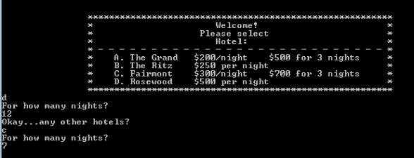
The menu is provided. The program needs to accept any of the characters A, B, C, or D – in either uppercase or lower case.
Once a hotel selection and the number of nights have been input, the user needs to be offered a chance to also stay in a second hotel, and a third, and a fourth.
However, once a keystroke is input that is not one of these (A, a, B, b, C, c, D, or d), the program needs to stop offering additional hotel options, and calculate the total cost for hotels.
Assume each letter will only be entered once. For example, assume A or a will be entered only one time.
Output needs to show the total nights reserved (as an integer) and the total cost (as a decimal).

Grading:
Functionality 35%
Pricing accuracy 45%
Output completeness 25%

Due Date:_________________________________________

